**Lab: Artisan – Part One***Assigned: June 22nd  
Due: June 24th*

Create a one-page webpage for your favorite musician / band / poet / artist.  It will eventually be expended to include links, images and more. The artisan can be living or dead. This will be an informational webpage discussing a brief history of the artisan.

You’ll create a page that gives a biography and list of some of the artisan’s work. This could be an album list, list of paintings, list of books they have authored, etc.

**Requirements:**

The webpage should have the following:

* Name the file your artisan.html
* Webpage created using core tags, including <!doctype>, <html>,<head> and <body>
* Name of the artisan in a <title> tag
* The name of the artisan to a h1
* Bio
  + Write a short biography about the artisan. It should have AT LEAST three paragraphs
  + Set the artisan birth year in italics.
  + Where the artisan in from in bold.
* Work
  + A short bulleted list of their work. Minimum of three examples
* Go to [w3schools.com/tags/default.asp](http://www.w3schools.com/tags/default.asp), explore and choose an HTML tag that we have not discussed yet in class. Read the documentation about the tag and how it structures. Please do NOT choose the <img>, <audio>, <video>, <canvas> or <form> tag
* Make sure to include <meta charset=”UTF-8″>into the <head> section to assist with webpage validation
* Use the HTML validator here: <https://validator.w3.org/>  
  Use the settings issued in this [PDF](http://davidhurwich.com/teaching/des117/validator.pdf) or read the validator PDF on the Resources section of the Smartsite and make sure your webpage validates correctly.

*Lab Hints*

Make sure your lab file ends in “.html” otherwise it will not work correctly.

Make sure that your structure is correct, meaning <!doctype html> tag comes first, then <head>, then <body>

There should be no content ( <p>, <h1>, <h2>) in the <head> section

**Dropoff**

* Students will submit the HTML page labelled as “lastname-firstname-artisan.html”
* Student will take a screenshot of the validation page after ther webpage has been properly validated
* Students will submit the lab to the class folder under **Pickup > Labs > Lab1-Artisan**
* Student will create a new folder in their Smartsite Labs folder called “*Lab1-Artisan”*
* Student will upload the lab HTML page/validation screenshot to the new Smartsite folder called “*Lab1-Artisan”*

**Artisan Lab – Part Two**

In this lab you will take the artisan.html page you created in lab one and extend it by adding images and hyperlinks. You’ll begin by creating a root folder called ‘Artisan”Add your artisan.html to the root folder

**Requirements**

* Create a banner image to go at the top of the artisan page. Use Adobe Photoshop or related program to create the banner.
* Create the banner with the following criteria
  + - 800px x 600px
    - RGB color space
    - 72 PPI
* You’ll add a minimum of THREE images related to the artisan. They can be personal photos, art work, album covers, etc. You’ll place them below the original text and list.
* Add an unordered list of links to related websites, social media and articles related to the artist.

[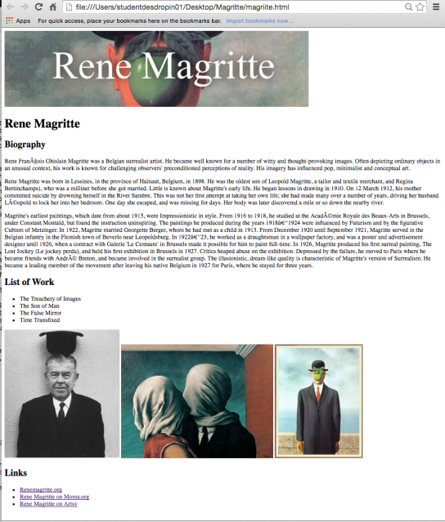](https://des117blog.files.wordpress.com/2016/06/94816-lab2.png)

**Dropoff**

* Students will submit a folder containing the HTML document AND ALL of the images with the name “lastname-firstname-Lab2-Artisan”
* Students will submit the lab to the class folder under **Pickup > Labs > Lab2-Artisan**
* Student create a zip file of the finished folder and upload it to the their Smartsite Dropbox into their Labs section under the name *Lab2-Artisan.zip*
* Students will upload the folder to their FTP servers assigned in class.
* Instructions for FTPing can be found in the FTP folder found on the *Smartsite > Resource* section
* Students will create a url to their webpage. Students will upload that url to their DES117 course blog

**Artisan – Part Three**

In this lab you will take the artisan.html page you created in lab one and two and extend it by an HTML5 containers and forms.

**Add a Fan Newsletter Form**

Students will add a short form to their artisan page asking people to sign up for a newsletter about the artisan. The form should come at the end of the page after the list of related media links.

The form MUST ask for the minimum of the following

* Name
* Email address
* Dropdown of topics about the artisan they are interested about for instance “news, new album, gossip, etc.
* A checkbox of whether they would like to added to the ‘official’ mailing list.
* A Submit Button

**HTML5 Containers**

Students will use HTML5 containers to organize artisan.html page

Students MUST

* Put the banner image, artisan name into a <header> tag
* Put the biography, image gallery, link gallery, Fan Newsletter form each into <section> tags
* Put the <section> areas within a <main> tag
* Add images in the image gallery into a <figure>
* Add a description for the image into a <figcaption>
* Add a <footer> to the bottom of the page. Include copyright information as well as some legal information.

**Dropoff**

* Students will submit a folder containing the HTML document AND ALL of the images with the name “lastname-firstname-Lab3-Artisan”
* Students will submit the lab to the class folder under **Pickup > Labs > Lab3-Artisan**
* Student create a zip file of the finished folder and upload it to the their Smartsite Dropbox into their Labs section under the name*Lab3-Artisan.zip*
* Students will update their students’ servers with the NEW version of artisan.html